|  |  |
| --- | --- |
| Assignment 3  Manual | Abstract  This is an easy to follow step-by-step manual that will guide technicians on how to assemble desktop PCs and distribute an image to laptops that don’t have an optical drive  Lu,Jamie  IT Database Administration |

Table of Contents

Materials List 1

INSTALLATION 1

PART A: Physical Installation 1

Step 1: REMOVE THE OLD MOTHERBOARD 1

Step 2: INSTALL THE NEW MOTHERBOARD 8

Step 3: INSTALL THE CPU 8

Step 4: INSTALL THE RAM 11

Step 5: INSTALL THE HARD DRIVE 13

Step 6: RECONNECT THE SYSTEM PANEL LIGHTS AND BUTTONS 17

Step 7: RECONNECT POWER CABLES 17

Step 8: CLOSE THE CASE 18

PART 2: Software Installation 19

Step 1: BIOS 19

Step 1.1 UPDATE THE BIOS 19

Step 1.2: CONFIGURE THE BIOS 20

Step 2: WINDOWS UPDATE 21

Step 3: UPDATE THE DRIVERS 21

Step 4: COPY THE IMAGE TO OTHER COMPUTERS 22

# Safety Practices

* Make sure to turn off and disconnect the power when working inside a PC. It is best to disconnect the cord entirely.
* Power supply is not a field serviceable unit. DO NOT take it apart because it can cause a fatal shock even when unplugged.
* Be careful of the sharp edges of the computer case. Do not FORCE things to move.
* Cleaning solutions can contain flammable and poisonous materials. Be careful when using them and avoid having them touch your skin or get in your eyes.
* Items like heat sink paste are toxic. Make sure to wash your hands after working on a computer.
* Do not have food in the work area.
* ESD or electrostatic discharge causes damages that are invisible and permanent. To avoid this, wear an antistatic bracelet and attach the grounding clip to the frame of the computer case.
* As much as possible, avoid working on carpet, especially during winter.
* While the computer is running, NEVER touch the components inside the computer.
* Verify that the CPU cooling fan is working after doing anything with it.
* Think ahead and always be cautious about each step.

# Materials List

## Upgrade Components:

RAM: Crucial 8GB DDR4-2400 UDIMM

CPU: Intel i3-8100 @ 3.60GHz

Motherboard: ASUS PRIME H370M-PLUS

Hard drive: Western Digital WD1600AAJS, 160GB

## Software:

Latest BIOS ROM

Clonezilla

## Tools and etc:

Antistatic bracelet

Thermal Paste

# INSTALLATION

# PART A: Physical Installation

## Step 1: REMOVE THE OLD MOTHERBOARD

1. Power off and unplug the computer. Unplug all the other wires plugged in.

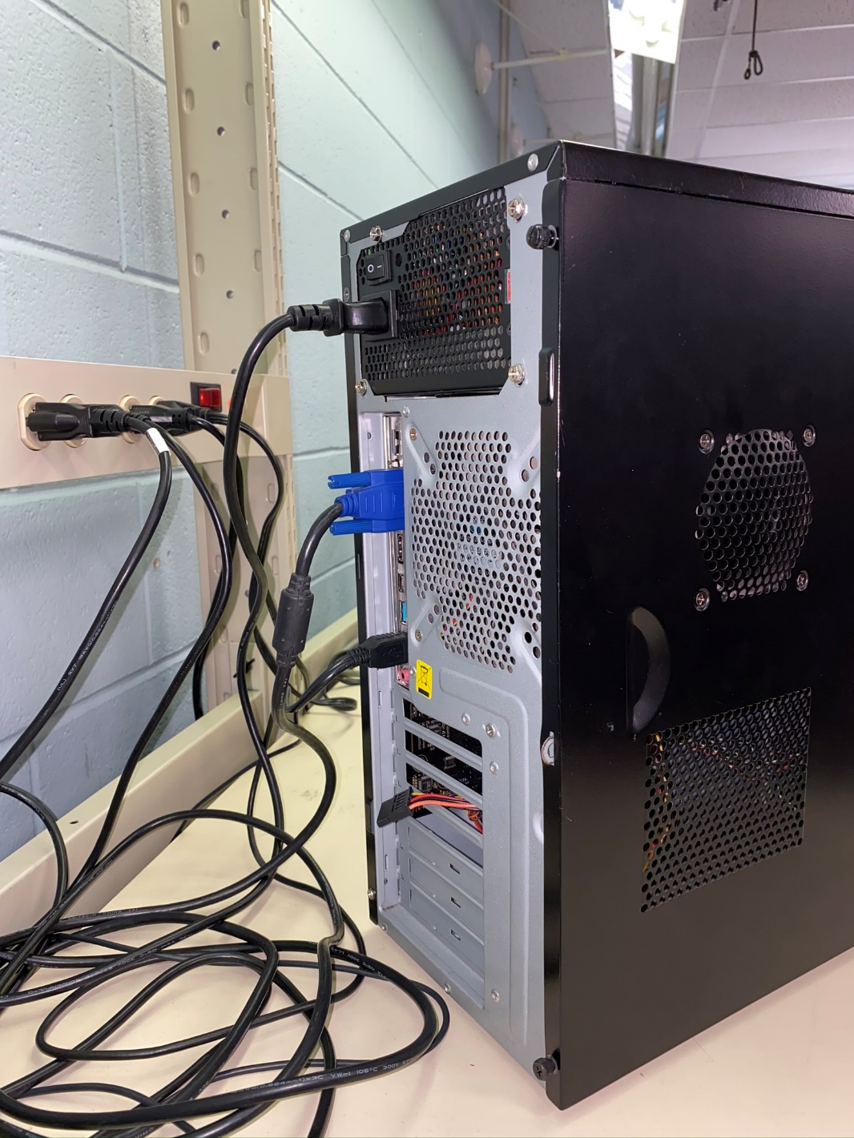

*Figure 1 – Back of the case with wire plugged in*

1. Remove the cover of the case.
   * Find the side that can easily be removed, usually screws that can be removed without a screwdriver. If there isn’t such, find the appropriate screwdriver to open the case.

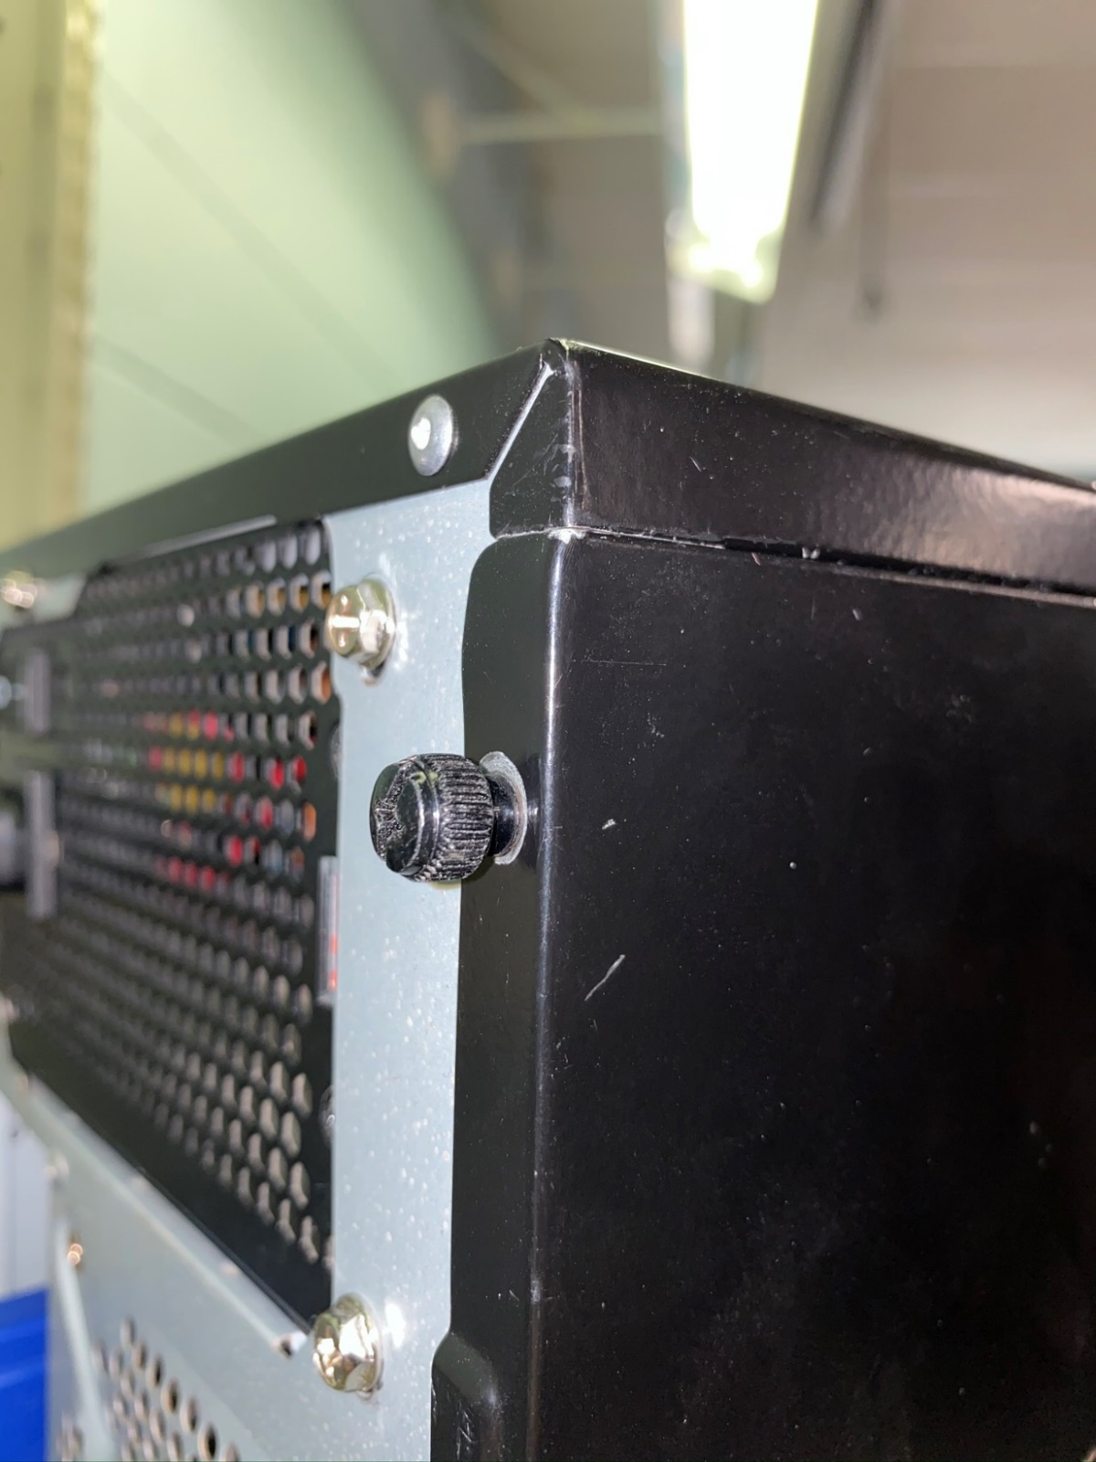

*Figure 2 – Screws that can be turned easily to remove the case’s cover without tools*

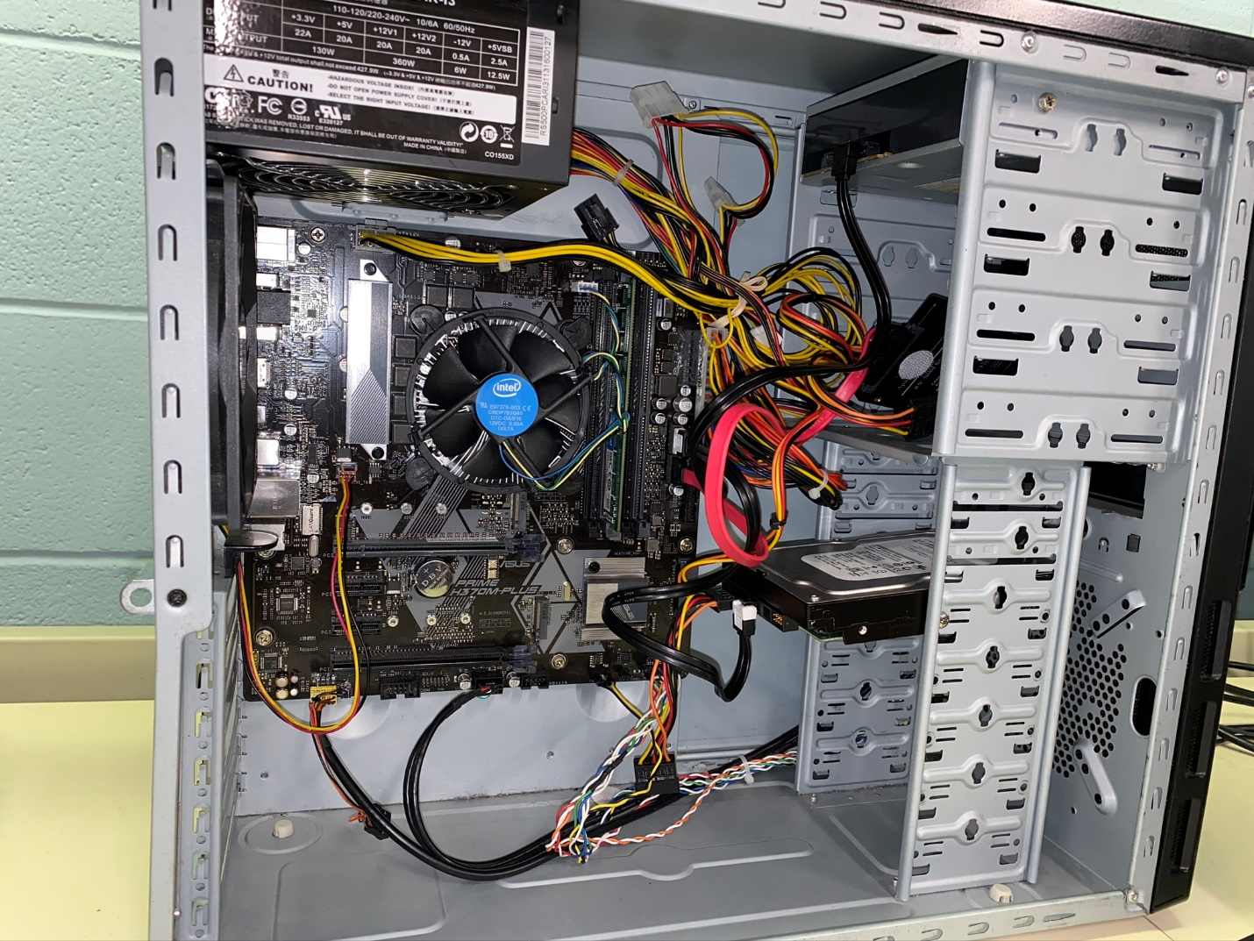

*Figure 3 –Inside look. Everything is still attached.*

1. Remove the cables the optical drive(s) and hard drive(s).
2. Remove the power cables.
3. Remove the RAM.
4. Remove any expansion cards present.
5. Remove the CPU fan from the CPU socket.
   * Sometimes there are special plastic fasteners that lock the fan in place. These can be unlocked using your fingers.
   * Gently lift the fan away from the socket in order for the motherboard to be lifted out without fuss.

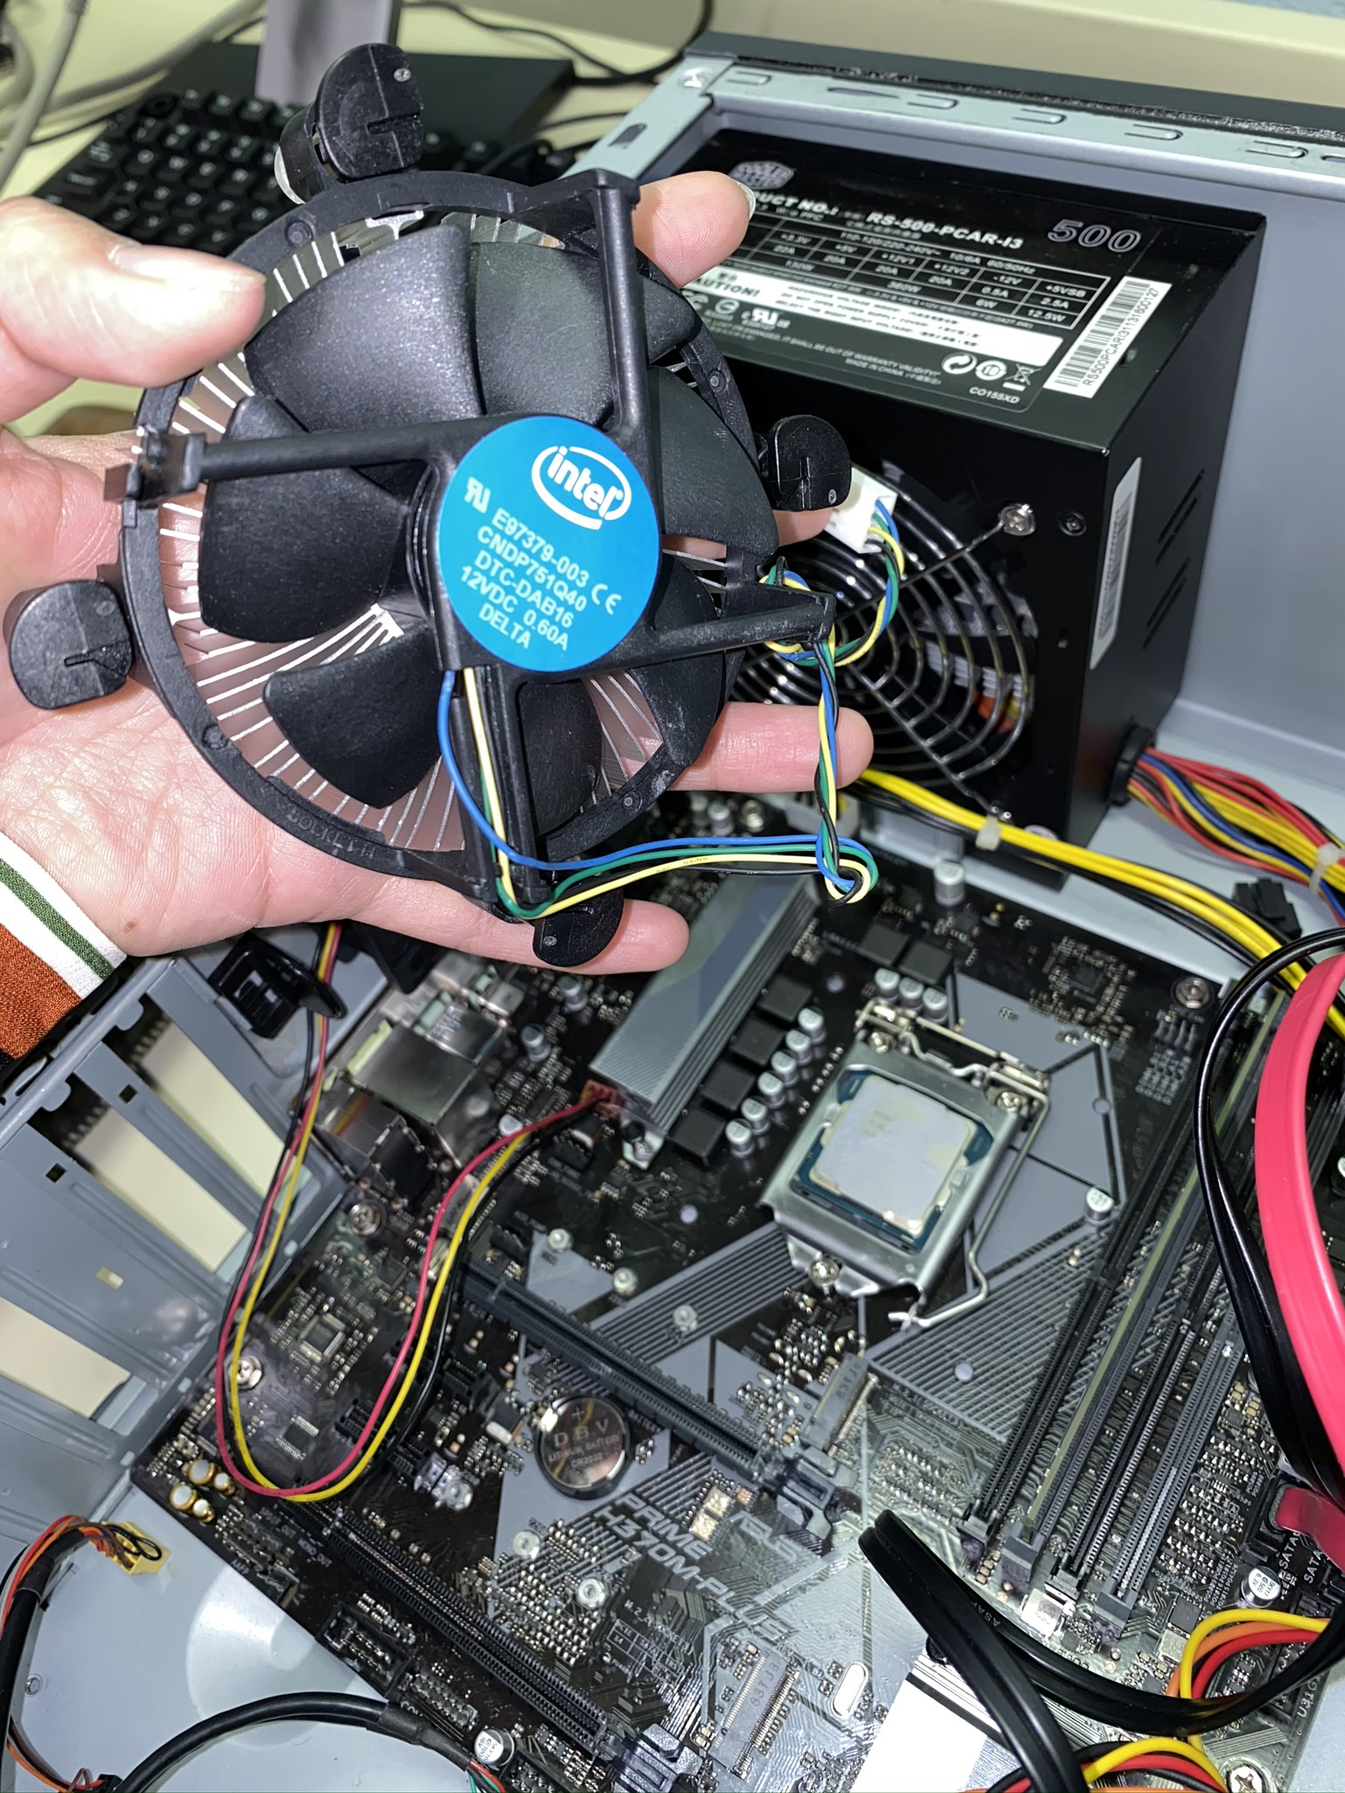

*Figure 4 – Fan detached*

1. Remove the motherboard.
   * Find the screws that secure that motherboard to the case and unscrew them using the appropriate screwdriver.
   * Carefully set the screws aside as you need them later when you install the new motherboard.
   * Once all the screws have been removed, you can now gently remove the motherboard from the case.

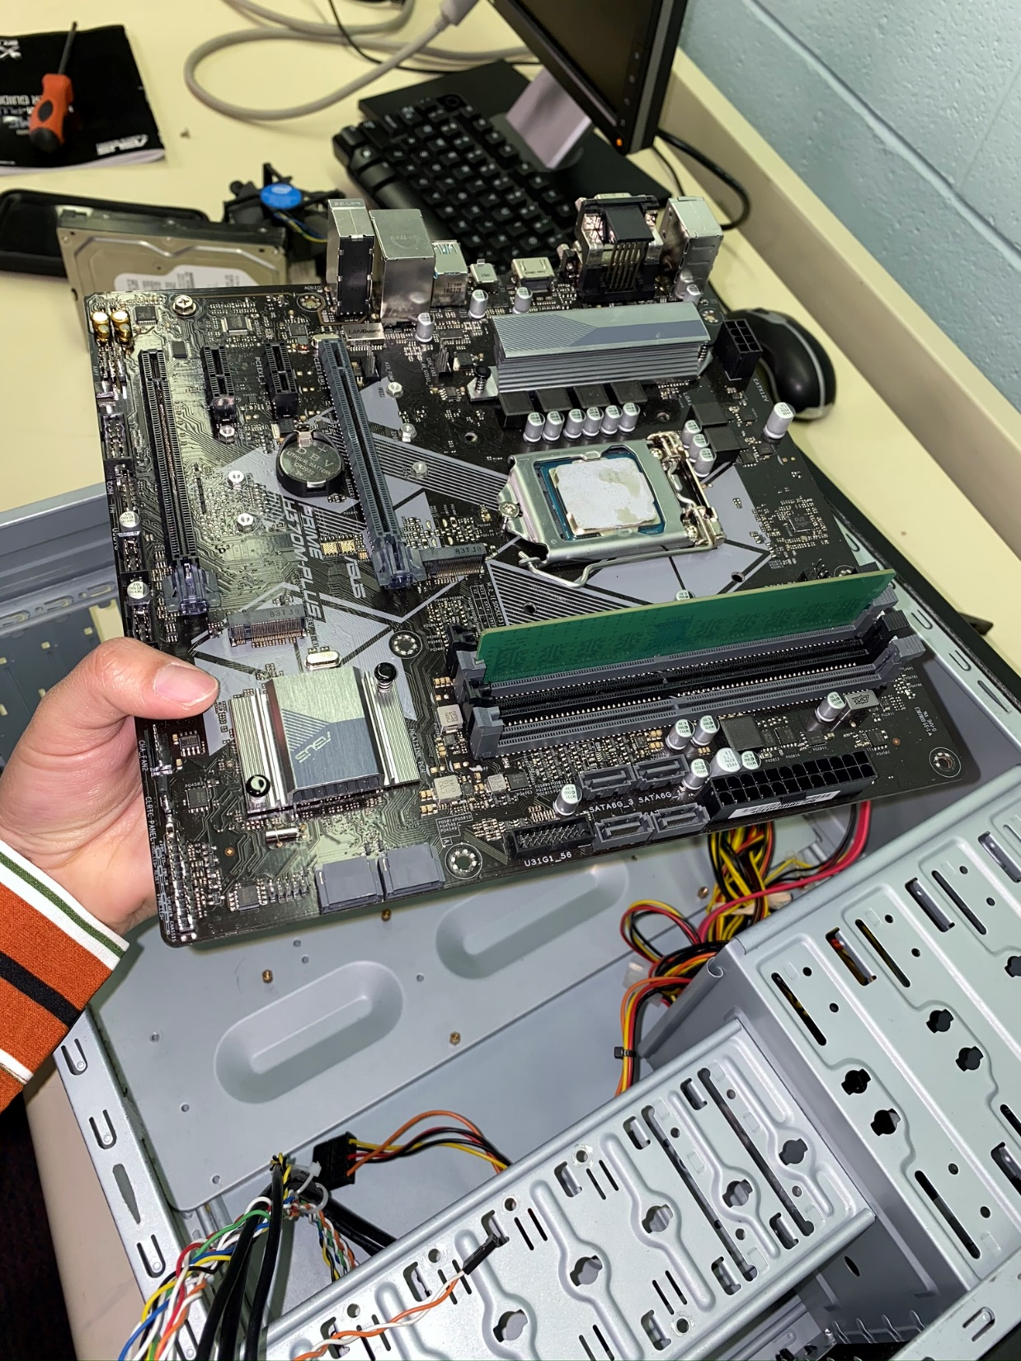

*Figure 5 – Motherboard removed*

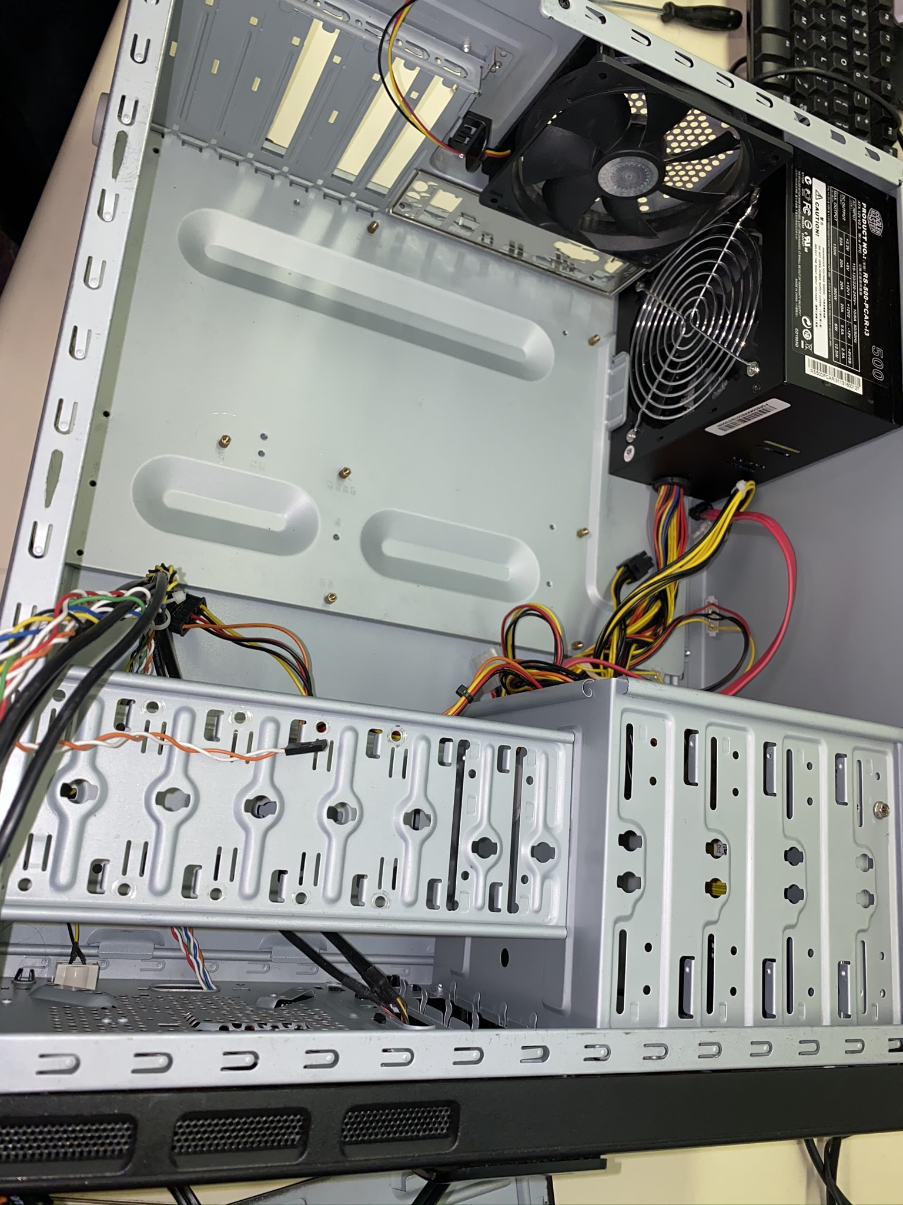

*Figure 6 – No more motherboard*

## Step 2: INSTALL THE NEW MOTHERBOARD

1. Get the new motherboard.
2. Carefully insert the new motherboard.

* Make sure the built-in ports are aligned with the appropriate holes on the case.

1. Use the screws that you set aside to secure the motherboard into place.

## Step 3: INSTALL THE CPU

1. Using the ZIF or zero-insertion-force level, open the socket.
2. Insert the new CPU
   * There are notches along the outer part of the CPU and socket.
   * Be careful not to put the CPU upside-down. There are shiny parts on the socket and these match up to the shiny parts on the CPU.

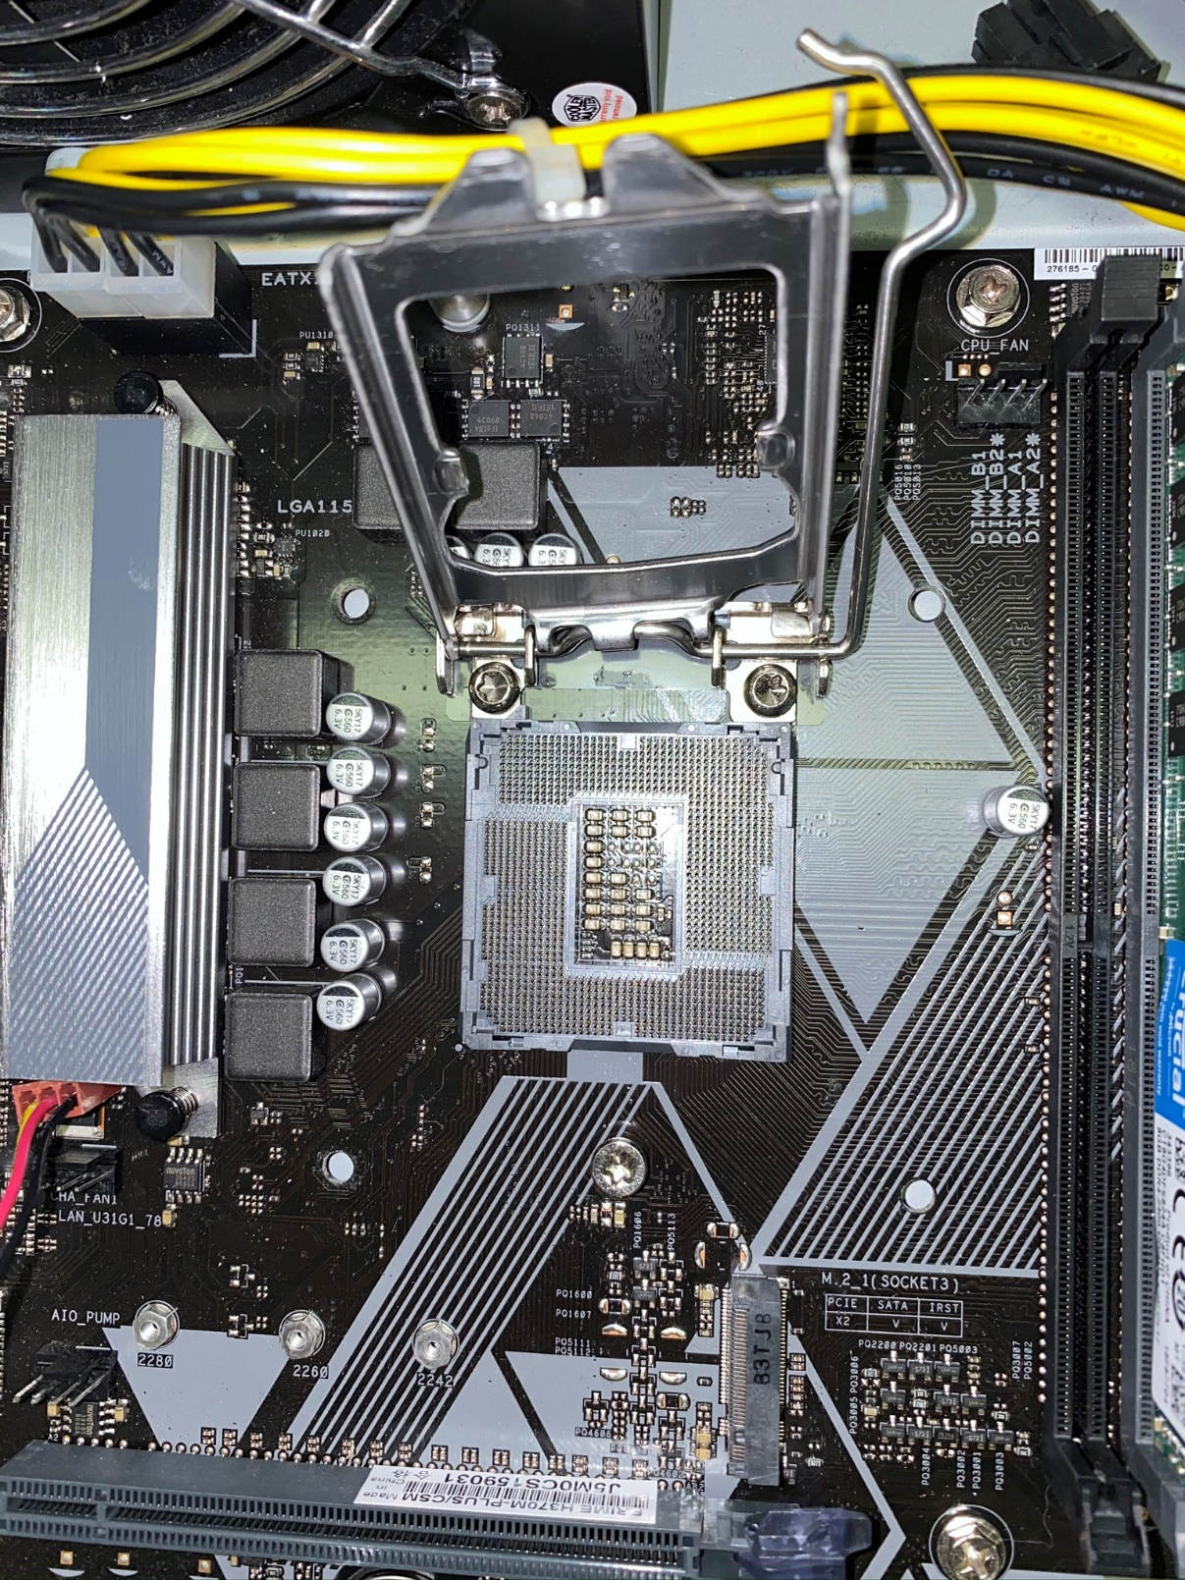

*Figure 7 – Opening the CPU Socket and removing the old CPU*

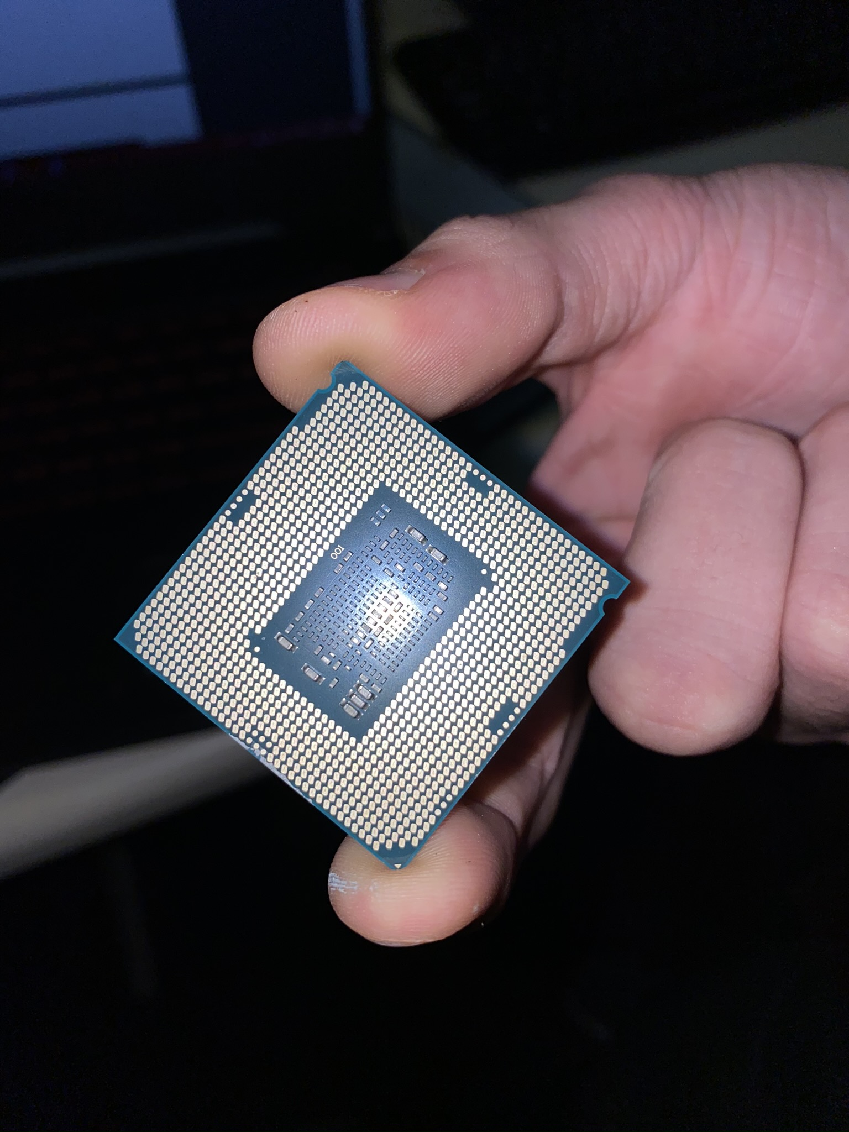

*Figure 8 – The CPU*

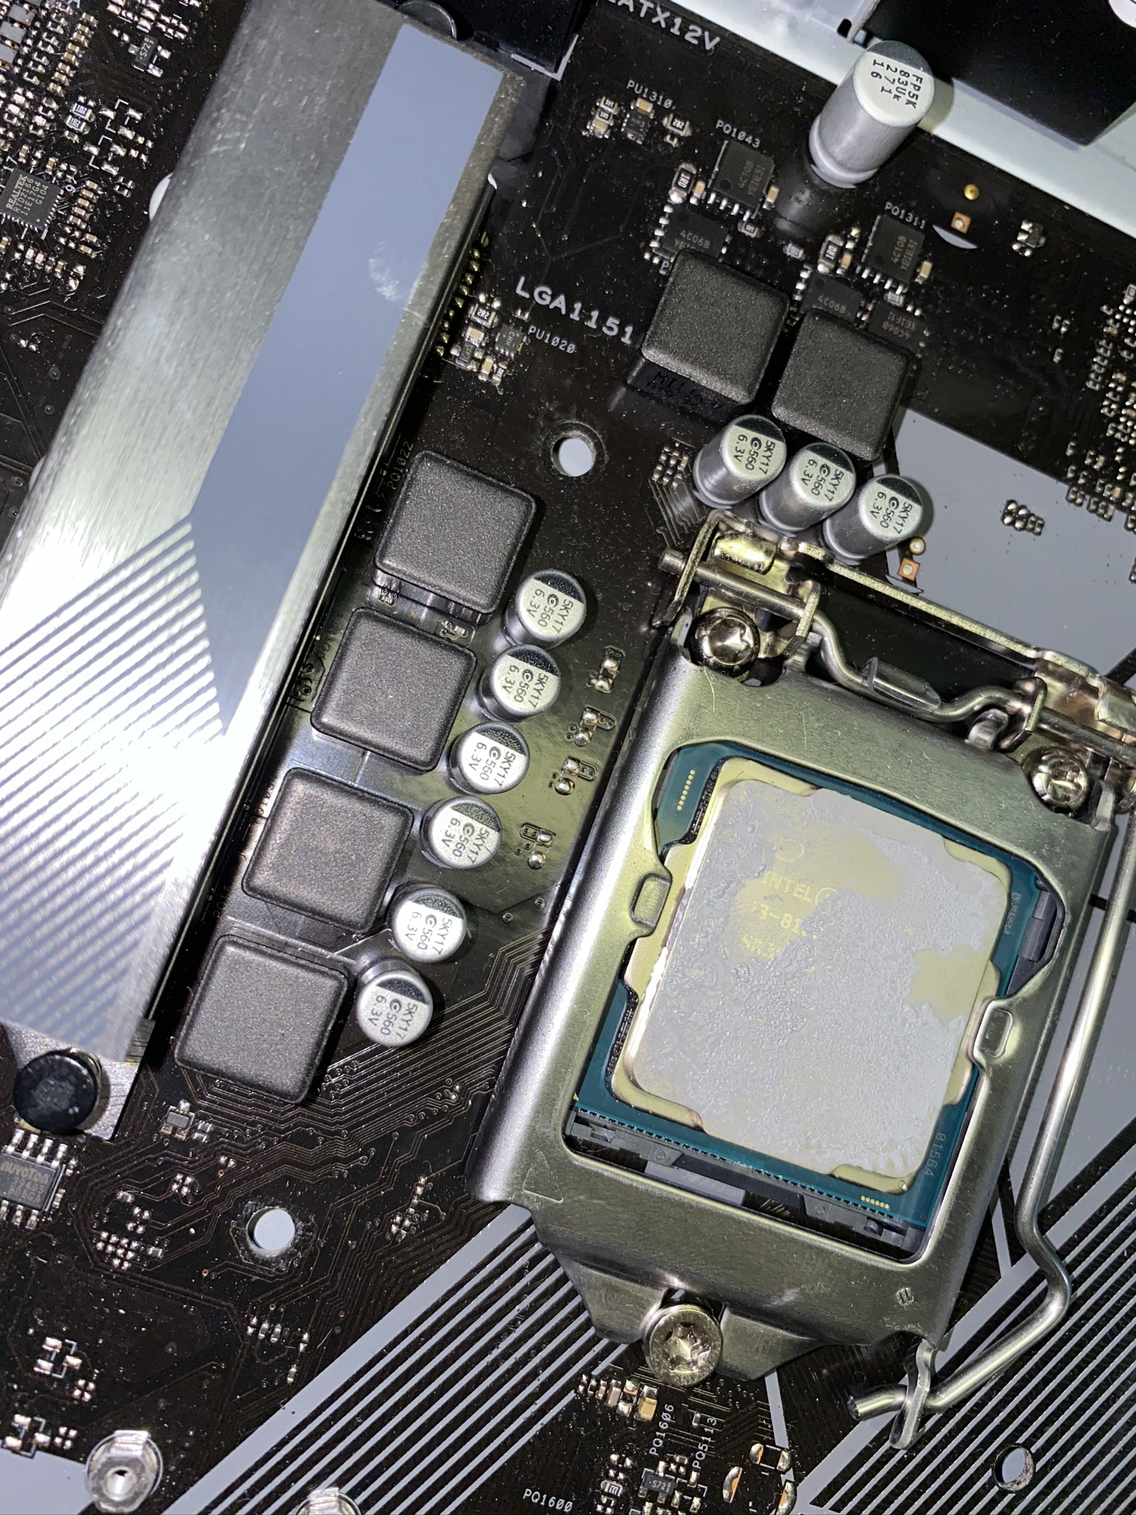

*Figure 9 – Installing CPU*

1. Put the cooler back on the top of the CPU.
   * It is very important for the fan to function. When CPU is not decently cooled, the CPU could overheat and get damaged permanently.
   * Make sure that the fan is receiving power by checking if the power wires are connected to the motherboard.
   * A good tip is that you should not attach the case during the first time you boot for you to see if the fan is working.
2. Enter the BIOS setup by pressing the delete or F2 key while the system is booting.
   * By going into Power 🡪 Hardware Monitor, you can take note of the CPU’s temperature.
   * There is also recommended temperature guidelines for the specific CPU, this can be seen when you check the CPU documentation.

## Step 4: INSTALL THE RAM

1. Install the RAM into the slots.

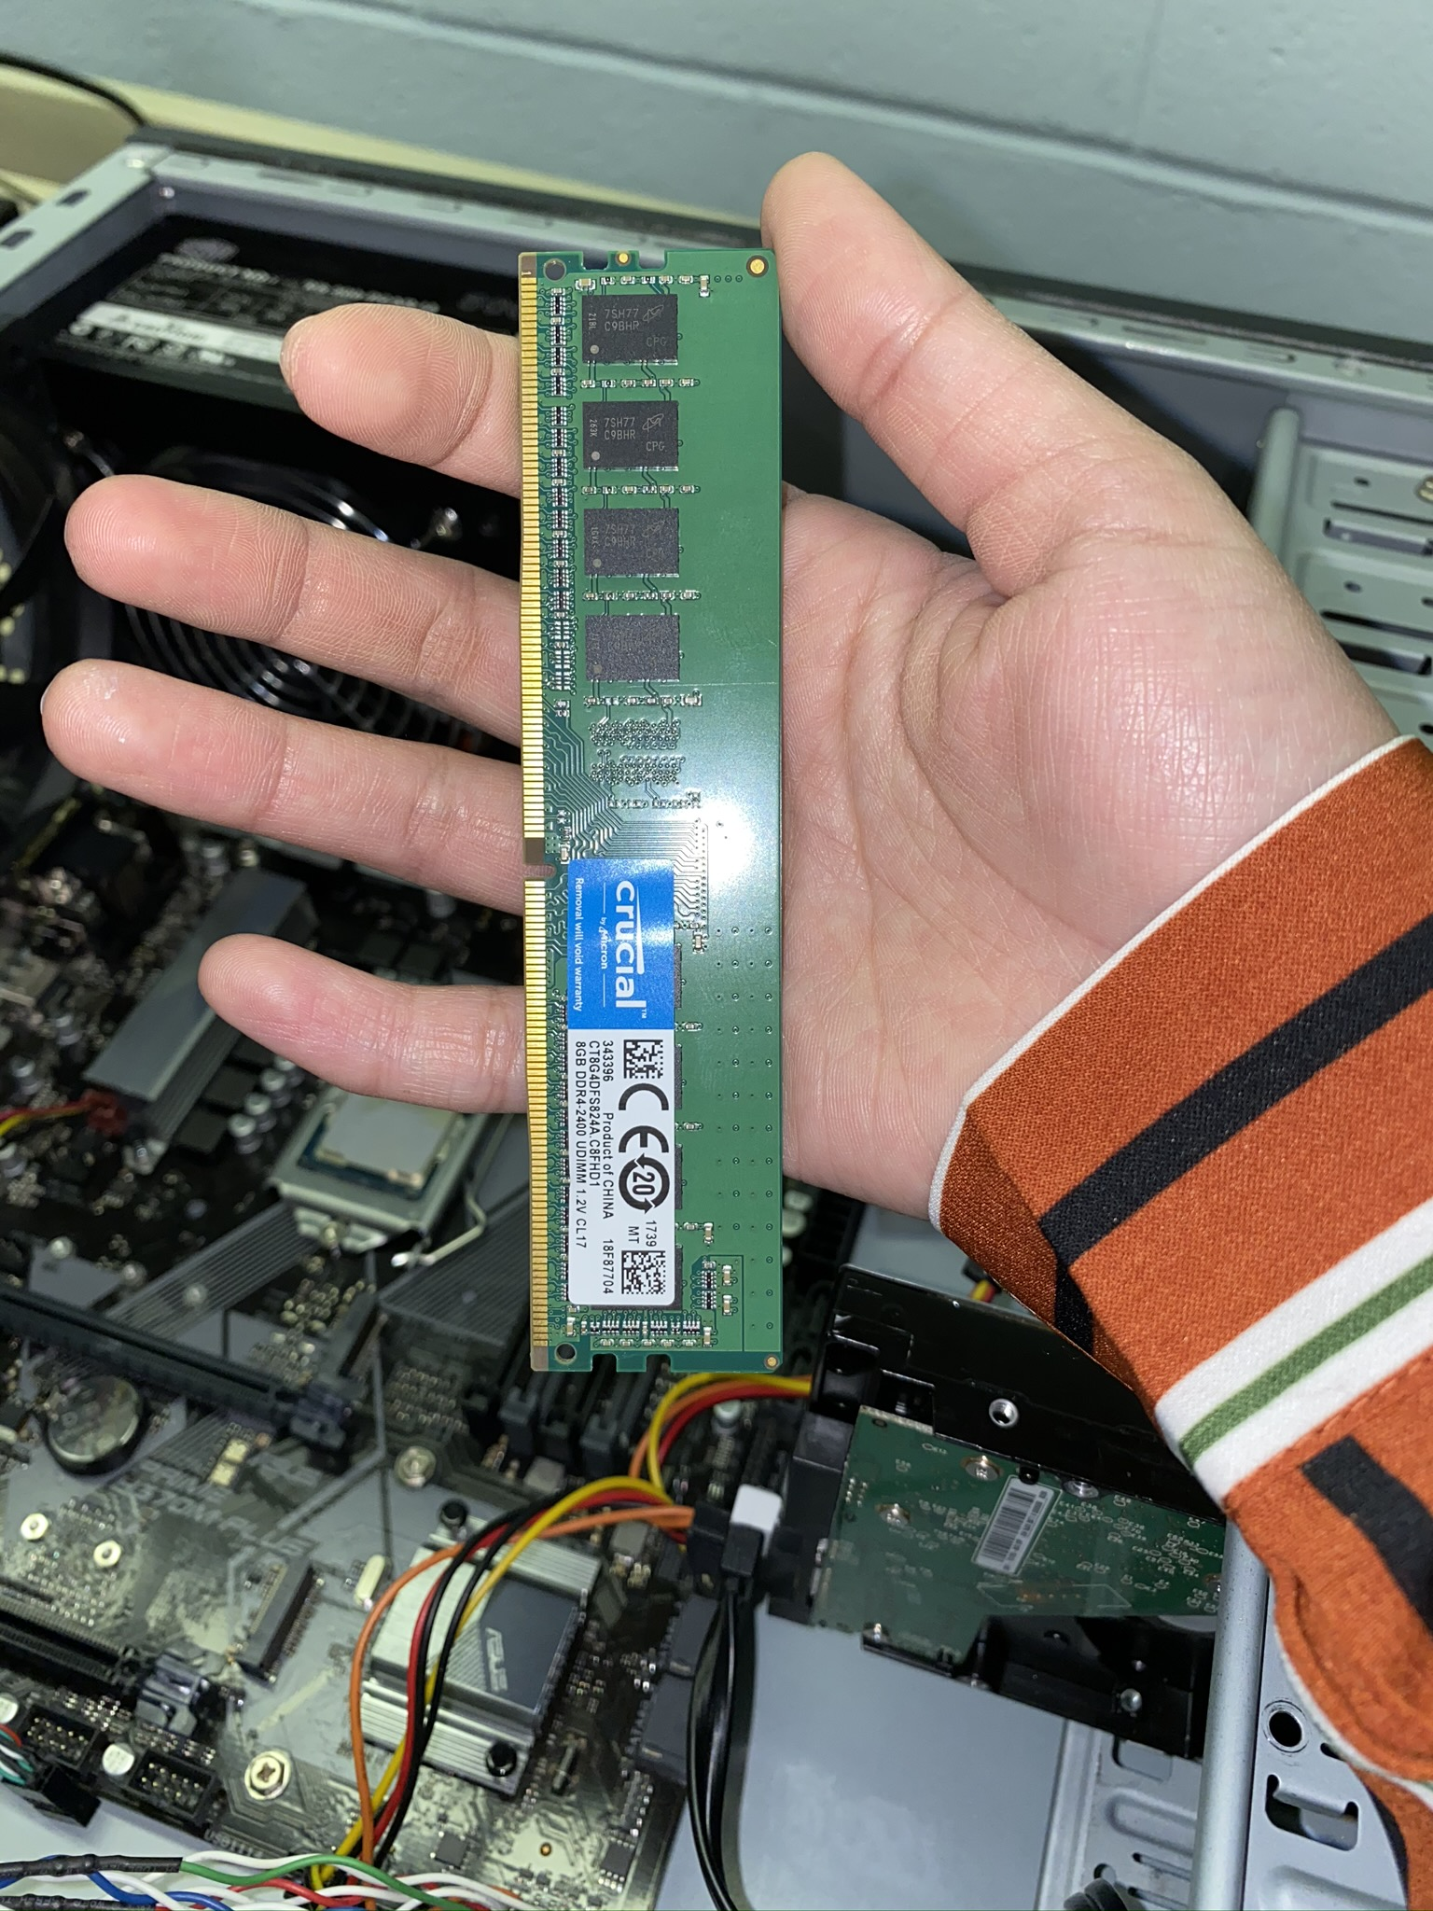

*Figure 10 – The RAM*

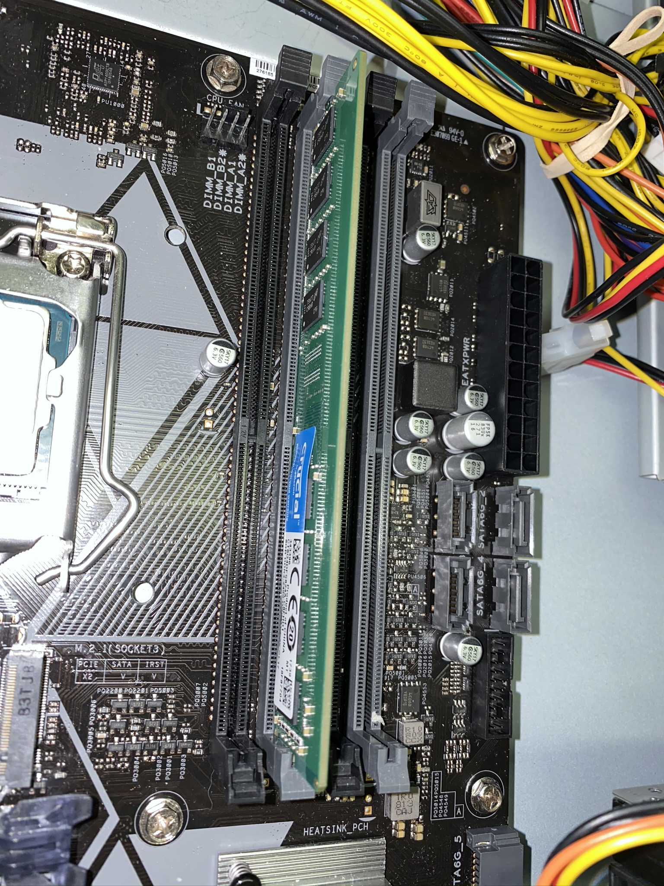

*Figure 11 – Installing the RAM*

## Step 5: INSTALL THE HARD DRIVE

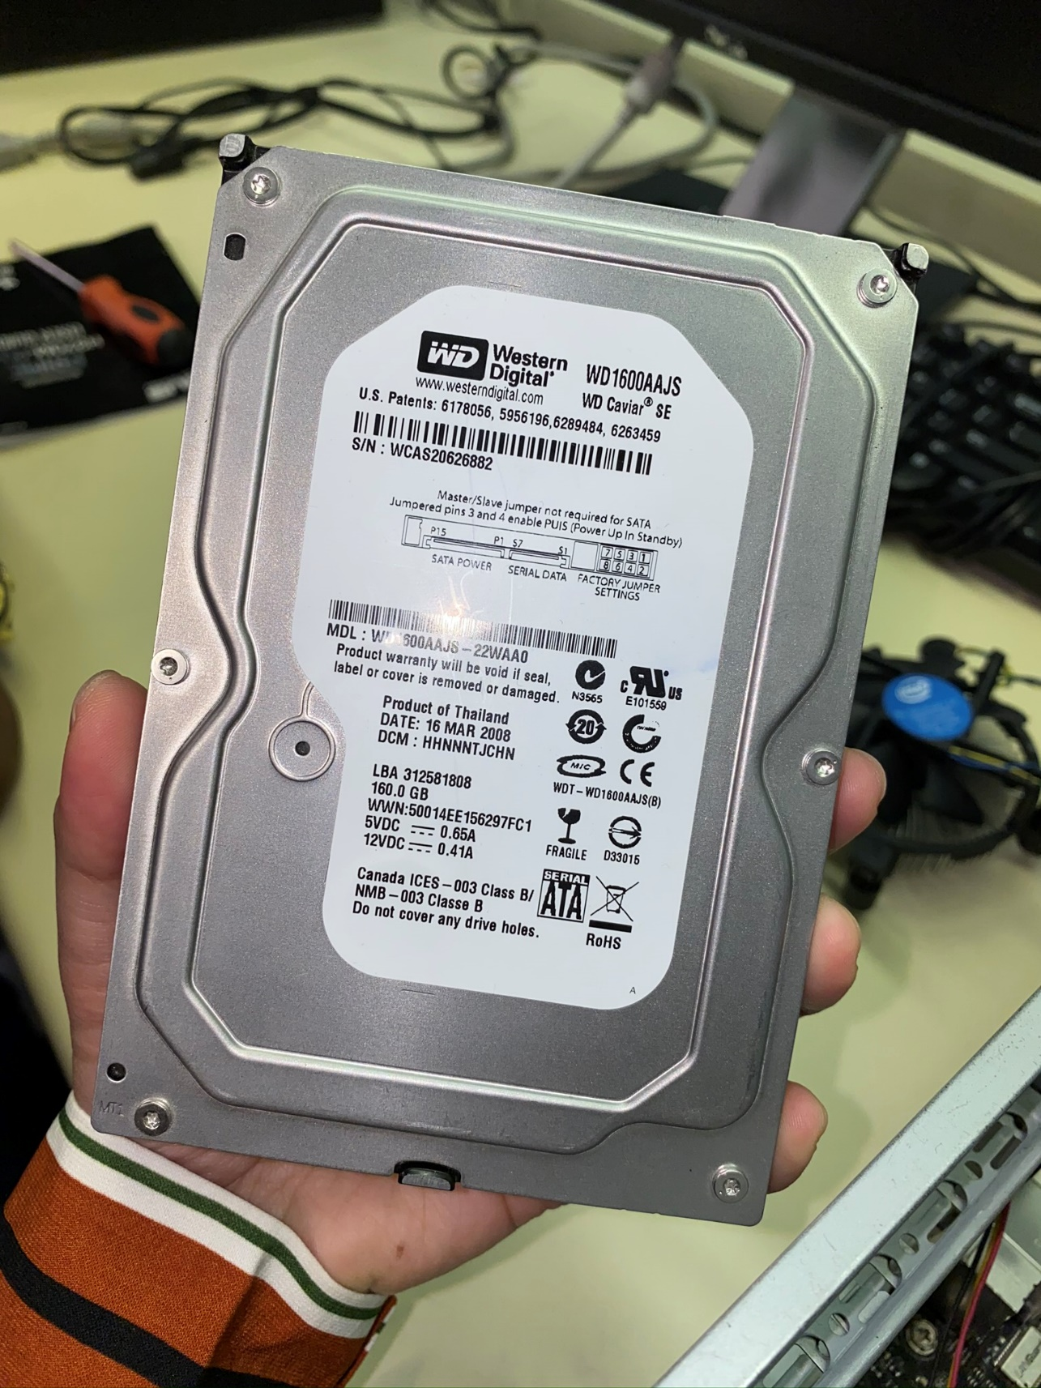

*Figure 12 – Front of Hard drive*

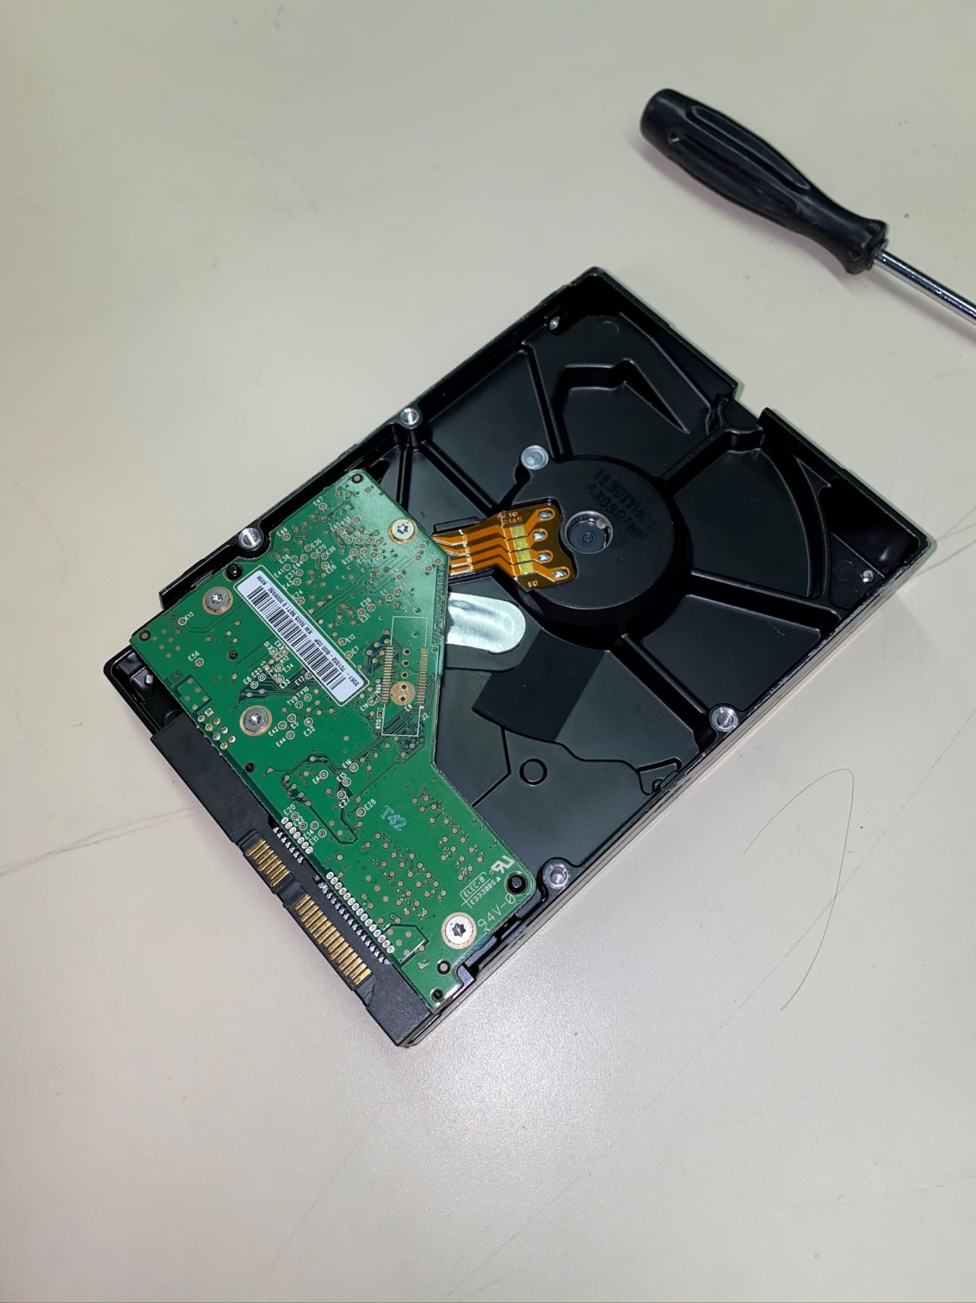

*Figure 13 – Back of Hard drive*

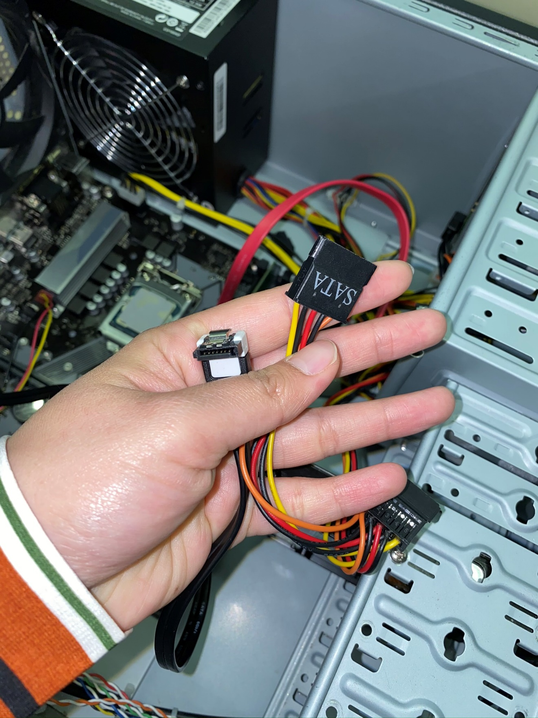

*Figure 14 – Wires to connect to the Hard drive: SATA and Serial Data*

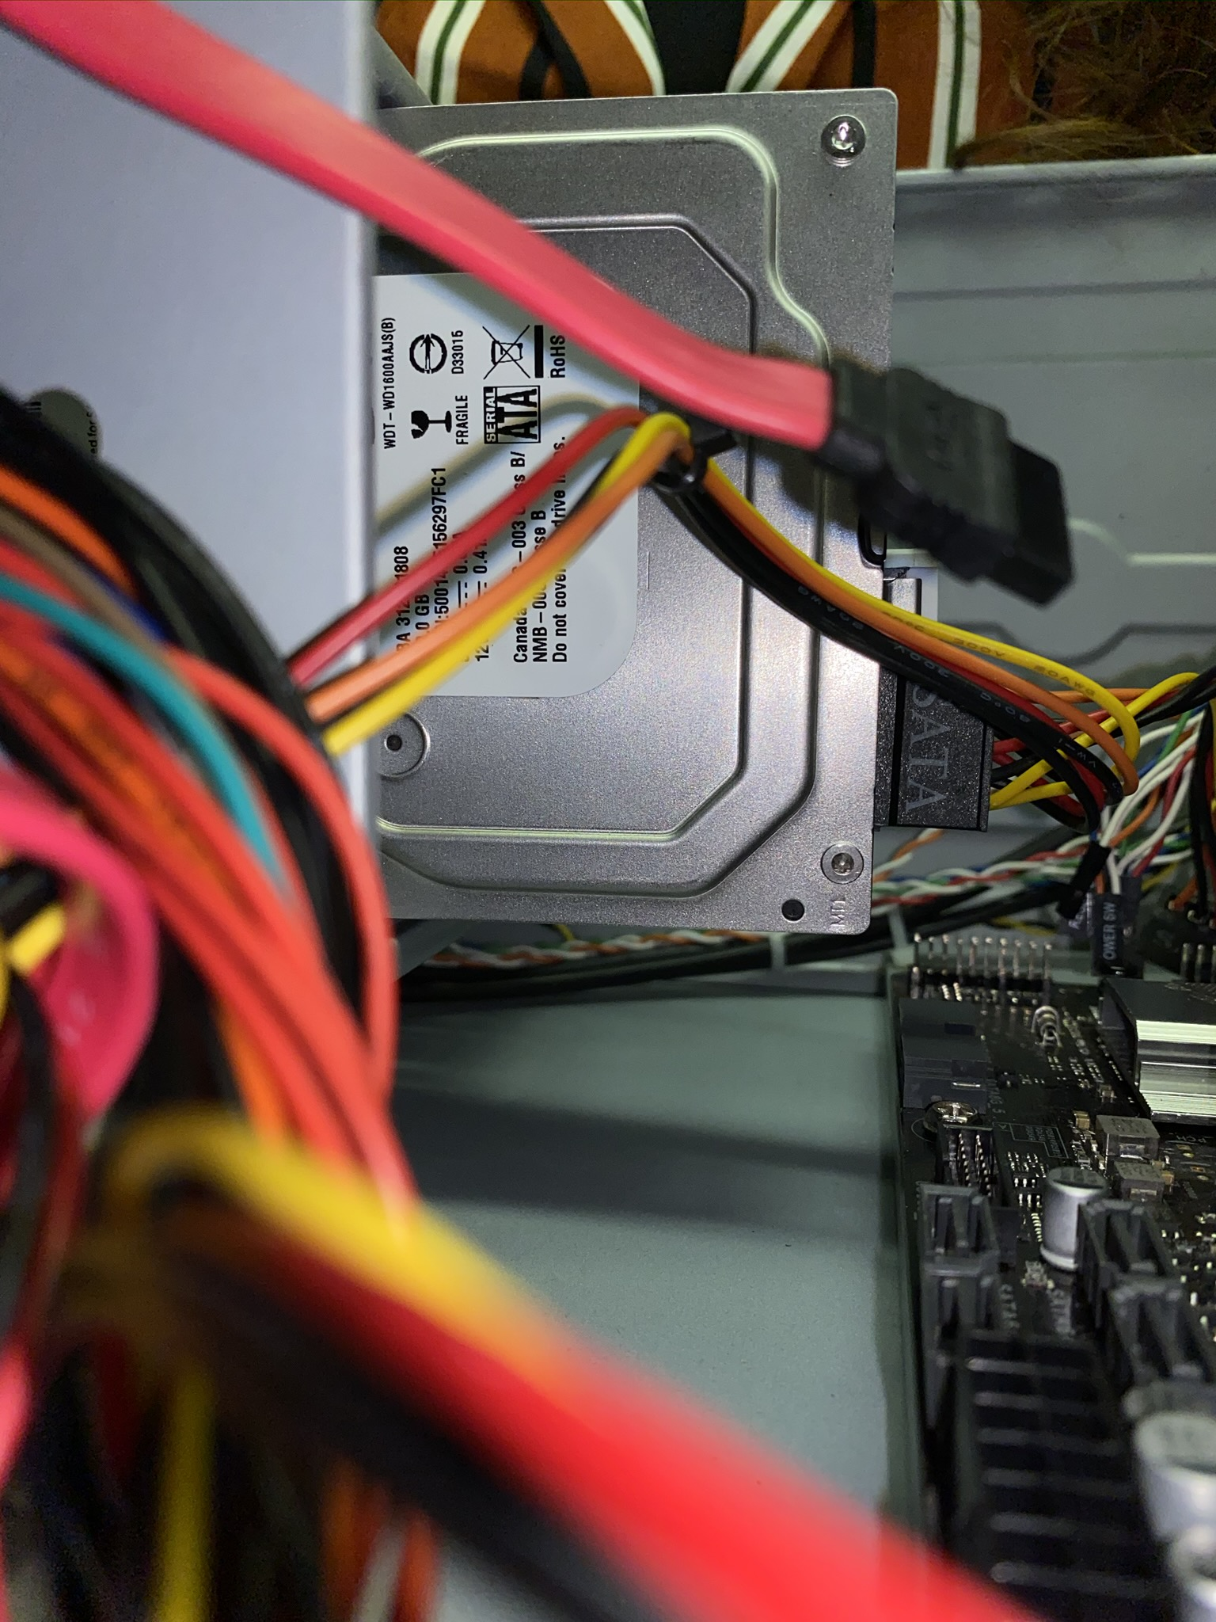

*Figure 15 – Hard drive attached*

## Step 6: RECONNECT THE SYSTEM PANEL LIGHTS AND BUTTONS

1. Using the manual of the new motherboard as reference, reconnect the system panel LEDs and buttons.

## Step 7: RECONNECT POWER CABLES

1. Reconnect the power connection between the motherboard and the power supply.

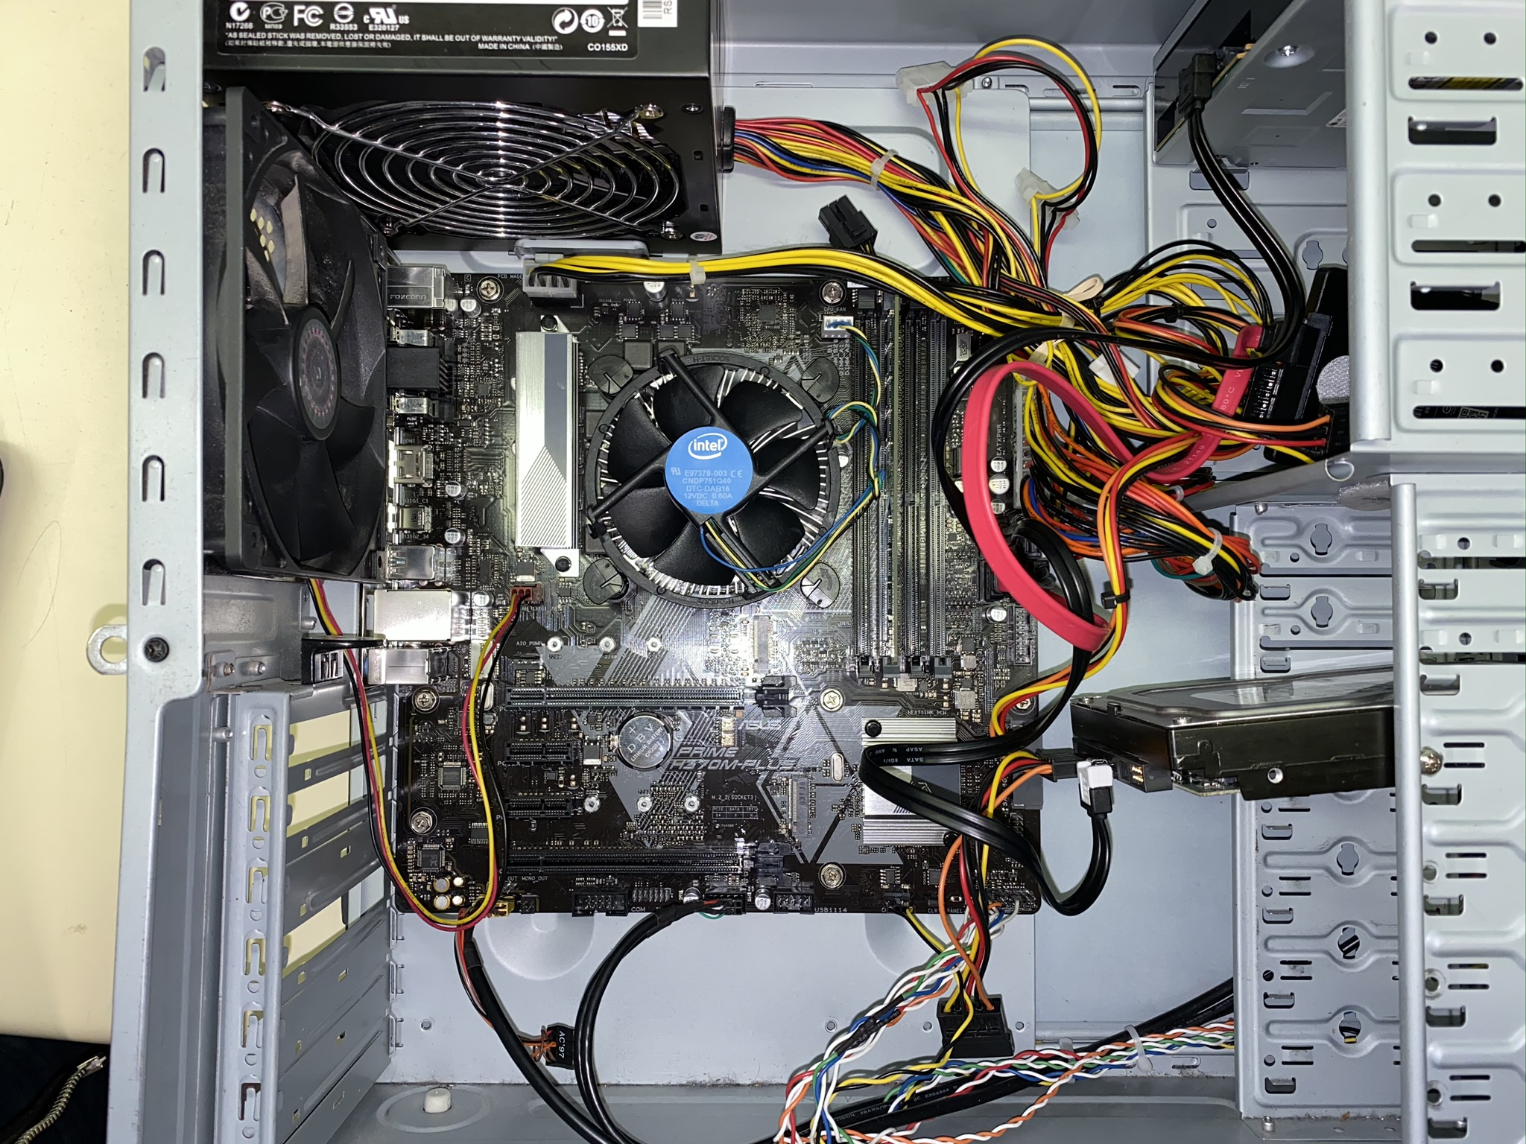

*Figure 16 – Reconnected Cables*

## Step 8: CLOSE THE CASE

1. Once all the hardware installation is done and everything is working well, you can now close the case and lock it.
2. Once the case is close and locked, reconnect the system to the power and peripherals.

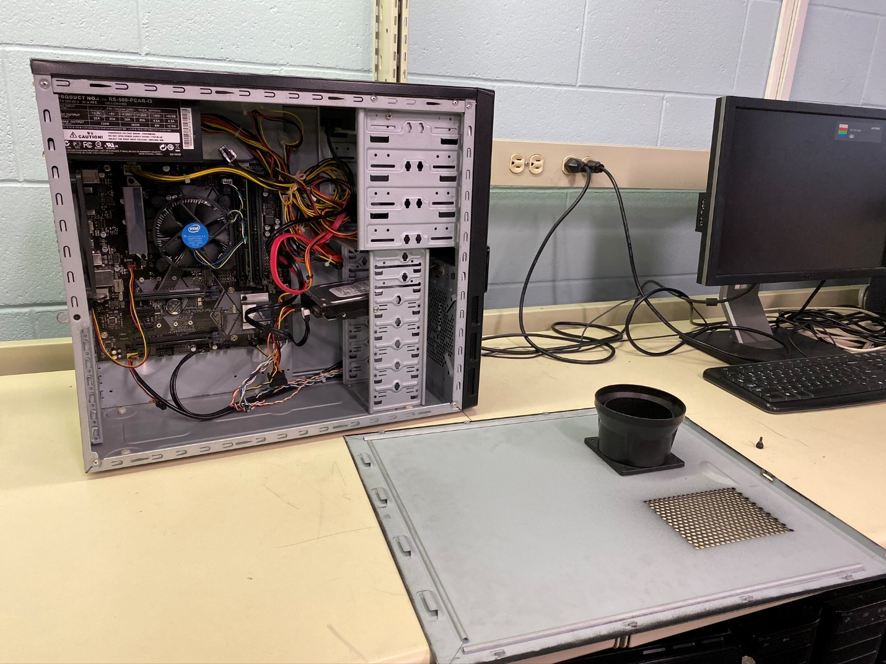

*Figure 17 – Before the case is put back*

# PART 2: Software Installation

## Step 1: BIOS

### Step 1.1 UPDATE THE BIOS

a) Check the version of BIOS the computer currently has. This can be done by typing msinfo32.exe in the Start Menu search field and running System Information.

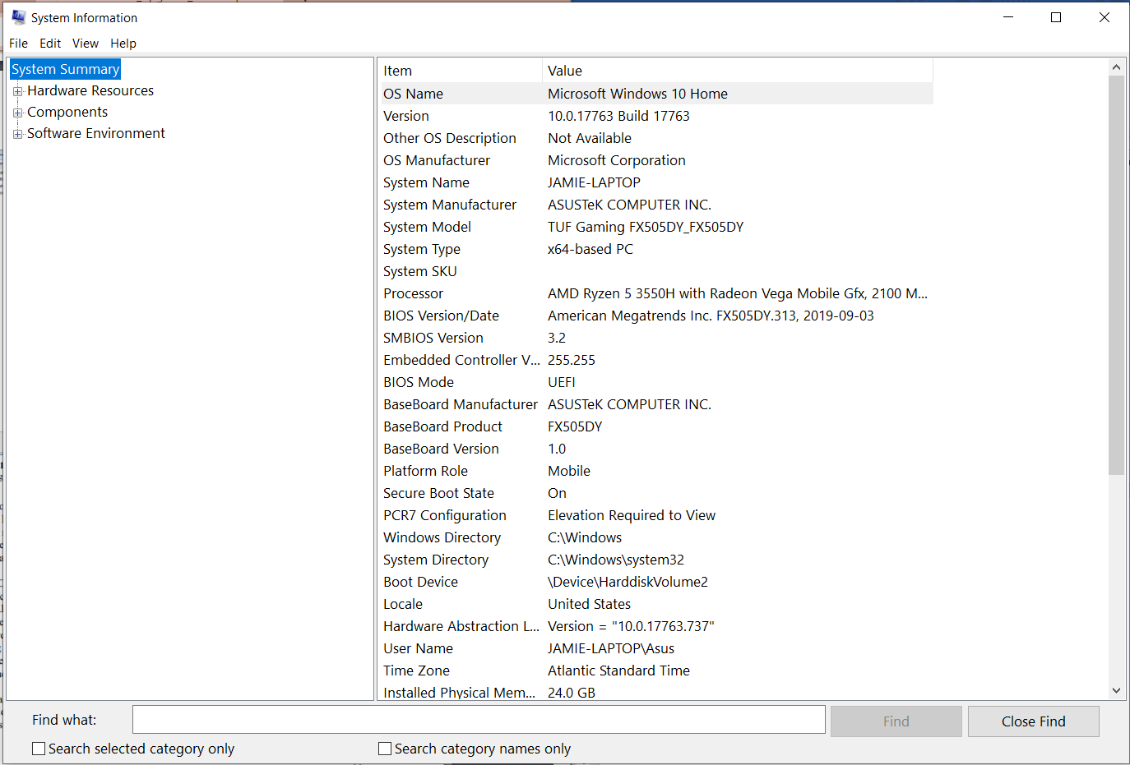

*Figure 18 – An* ***example*** *of what The System Information looks like. Take note of the BIOS Version/Date.*

b) Go to the manufacturer’s website and find the latest BIOS update for your system. If you need to update the BIOS, find the correct one for your operating system and download the file.

c) Once the file is fully downloaded, you’ll see that the BIOS is contained in a ZIP file. This means that you will need to use a program (for example WinRAR) to extract the file. You can save a copy of this file on a storage device to help in upgrading multiple computers.

d) Reboot the computer and press Delete to enter setup in order to start installing the upgrade. Go to tools and select “ASUS EZ Flash 2” and then start the utility. After that, press TAB to switch between the drive list and the file list. *The drive letters might be different as the ones you see in Windows.* Highlight the .ROM file and load it by pressing Enter and going through the prompts. Make sure the power stays on as interrupting the flash might ruin the BIOS.

### Step 1.2: CONFIGURE THE BIOS

a) Set the clock. This can be done in the setup’s first screen. Press enter in order to move the cursor through h (hour) : m (minute) : s (second) and +/- to set the numbers. The same can be done with regards to the date (month, day, and year). *It is important to note that the changes made to the clock will immediately set it, even when it is not saved.*

b) Set a supervisor password. Do this by going to “Boot” then selecting “Security” and “Change Supervisor Password” then set the “User Access Level” when it appears. User access level is usually “Full Access” by default but can be changed to “No Access” (a supervisor password would be needed for Setup). *This will secure the system. This will enable access to the authorized people and avoid having just anyone access and make changes in the BIOS.*

c) Enable PXE boot. *This is enabling booting from LAN.* *This is disabled by default.* To enable it, you can go to the Advanced menu, select “LAN boot ROM” and enable it.

d) Change the boot device order. Select “Boot Device Priority” from “Boot”. Use the +/- keys to move the devices up and down and set the order. The hard drive is usually set as the first device for security reasons. The BIOS will have multiple attempts to boot a device that isn’t showing up or cannot be booted from until all possibilities are exhausted.

e) Exit and save changes by pressing F10. This can be done at any point in time.

f) Clear the BIOS settings

Within the setup program

Exit Menu 🡪 Load Setup Defaults 🡪 F10

Through Hardware

A hardware reset is used during dire situations when the setup program is not accessible.

Unplug System

Remove the case

Find the CMOS battery and nearby jumper (3 pins)

Have the jumper on “Clear RTC” or have it on the two pins that are closest to the battery

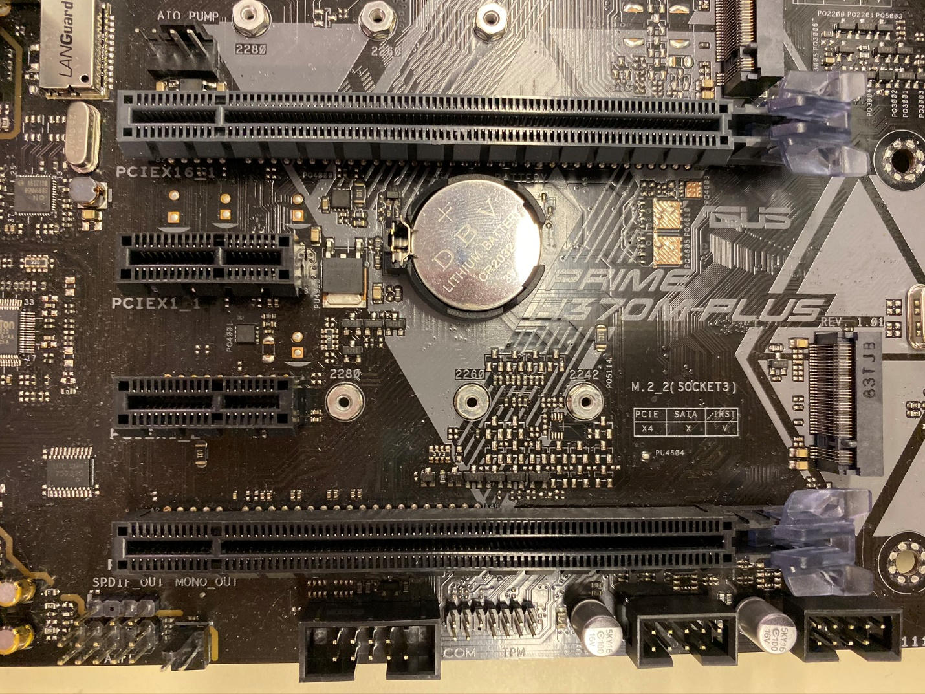

*Figure 19 – The CMOS battery and jumpers*

## Step 2: WINDOWS UPDATE

a) Go to the Start Menu, select “All Programs”, then select “Windows Update”.

b) To check for the latest Windows updates, click on “Check for updates” in the sidebar.

c) Select all the updates you need and press OK, then “Install updates” in the home screen.

d) To set automatic updates, click “Change settings” on the sidebar, and the drop down box has to be set to “Install updates automatically”, and a frequency must be set as well.

## Step 3: UPDATE THE DRIVERS

a) Go to the Start Menu, then Window’s Control Panel.

b) Click the Device Manager and search for the component you want to update drivers. Right click on the component you want and select “Update Driver Software”.

c) You can then choose to either search automatically for updated software or browse the computer for driver software. The latter is not really recommended unless there is a specific reason for it.

d) The update would then be installed and all the changes made will take effect once the computer has been restarted.

## Step 4: COPY THE IMAGE TO OTHER COMPUTERS

a) Use an image deployment software (example: Norton Ghost or Microsoft Development Toolkit). In this case, Clonezilla, an open source disk imaging program will be used.

b) Grab a USB drive and make the boot drive for Clonezilla Live. This can be done by first removing the current partitions and going to <https://clonezilla.org/liveusb.php> and follow the instructions on the website.

c) Boot the teardown computer from the USB drive mentioned in the previous step. This can be done by changing the boot order in the BIOS (if needed).

d) You can now start Clonezilla Live. This can be done by pressing Enter (default) and the language you would like to use (English is the default).

e) Once inside Clonezilla – Opensource Clone System (OCS) windows, you can now choose “device-image work with disks or partitions using images” which is the default.

f) Next, choose local_dev (default) in the Mount Clonezilla image directory window. This is when you can plug in an external hard drive. Press Enter.

g) Select which drive will hold the image you are going to make, then click <OK> or press Enter. After that, select “/”, this indicates where the image file will be saved. In this case, in the top (root) directory and press Enter (default).

h) You then have to choose Beginner Mode then press Enter (default). Choose Savedisk and hit Enter (default). Give the image file a name and press Enter.

i) Lastly, select the windows drive that will be the source disk for the image and press Enter. Clonezilla will then begin capturing the image of the Windows drive and it will save it as a file on the other hard drive. This process takes about 5 minutes.

# References

Asus. (n.d.). *Asus Prime H370M-Plus Manual*. Retrieved November 10, 2019, from Asus: https://dlcdnets.asus.com/pub/ASUS/mb/LGA1151/PRIME_H370M-PLUS/E13887_PRIME_H370M-PLUS_UM_WEB.PDF

Clonezilla. (n.d.). *Disk to Disk Clone*. Retrieved November 12, 2019, from Clonezilla: https://clonezilla.org/show-live-doc-content.php?topic=clonezilla-live/doc/03_Disk_to_disk_clone

Crider, M. (2018, October 12). *How To Upgrade and Install a New CPU or Motherboard (or Both)*. Retrieved from How-To Geek: https://www.howtogeek.com/348571/how-to-upgrade-and-install-a-new-cpu-or-motherboard-or-both/

Guloy. (n.d.). *Safety Precautions*. Retrieved November 11, 2019, from Computer Assembly for Dummies: https://computerassemblyfordummies.wordpress.com/overview/safety-precautions/

Matheson, W. (2012, April 10). *Workstation Upgrade Manual*. Retrieved from http://www.willmatheson.com/portfolio/resources/hdwr1/workstation_upgrade_manual.pdf

O'Reilly. (n.d.). *Replacing a Motherboard*. Retrieved November 9, 2019, from O'Reilly: https://www.oreilly.com/library/view/repairing-and-upgrading/059600866X/ch04s04.html

Spector, L. (2014, December 1). *When to image a hard drive, and when to clone it*. Retrieved from PC World: https://www.pcworld.com/article/2847308/when-to-image-a-drive-and-when-to-clone-it.html